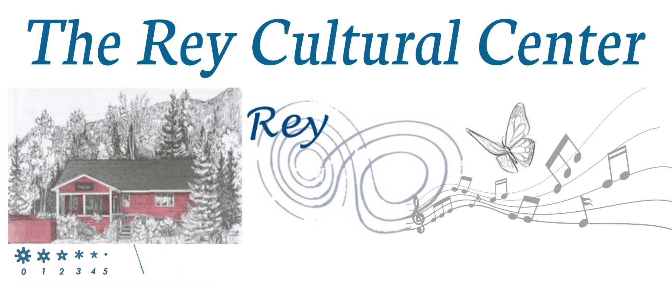

My total payment is $ _________________. I intend to pay via check by the first of each month, for the school year, beginning August 1st, mailed in or brought to Cottage.
**Monthly tuition is $850 and aftercare will be a flat monthly charge of and additional $216

- I have enclosed a check made out to The Rey Cultural Center.
- Electronic Payment available via paypal https://paypal.me/curiouscottage?country.x=US&locale.x=en_US

Student Health Information

Participant's Name ____________________________________Phone ____________________
Address ________________________________________City ________________Zip_______
Parent(s)/Guardian(s) Name(s) ____________________________________________________
Work Phone____________________________ Mobile Phone __________________________
Email Address _________________________________________________________________
Emergency Contact ______________________________________Phone__________________
(other than parent)
Physician's Name ________________________________________Phone__________________
Grandparent Contact information ___________________________________________________
Insurance Company Name_________________________________ Phone _________________
Policy#_____________________________________
1. Any severe allergic reaction to a bee sting or other allergen? YES NO
If yes, does your child carry an epi-pen?_________________________
2. Does your child use an inhaler? ____________________________________
*If your child has an epi-pen or inhaler, they must have it with them to participate in our program*
3. Any food allergies/dietary restrictions? __________________________________________
4. Currently taking any medications? If yes, specify type, dosage and medical condition.
____________________________________________________________________________
____________________________________________________________________________
5. Please describe any illnesses, surgeries, or injuries that may affect the participant's ability to participate fully and safely in the program (i.e. recent fractures, sprains, surgeries, etc).
____________________________________________________________________________
____________________________________________________________________________
6. Does your child have any special needs we should be aware of (any behavioral issues, family issues, learning disabilities, etc.)? If yes, please specify and suggest methods to help Rey Center staff best meet your child's needs. _____________________________________________________________________________
_____________________________________________________________________________
_____________________________________________________________________________
7. Any adverse reactions/allergies to medications? If yes, please specify___________________
______________________________________________________________________________
Medical insurance is the participant's responsibility. The Margret and H.A. Rey Center does not provide medical insurance during the program.

We give permission for our minor son/daughter to participate in these educational programs, and we authorize the Margret and H.A. Rey Center staff to obtain or administer medical treatment for him/her in the event of an emergency.

Signature ________________________________________________Date _______________
(Parent or Guardian)

Rey Cultural Center
Liability and Photo/Video Waiver Form

Liability Waiver
The undersigned is familiar with the risks and perils inherent in all activities he or she is engaged in at The Margret and H.A. Rey Center and Curious George Cottage [hereinafter the Rey Center], which include, but are not limited to, muscle pulls, neck and spinal injuries, heart attacks, heart rhythm abnormalities, other cardio respiratory problems and death, among others. The undersigned agrees to assume the sole risk of injury due to such activities. The undersigned also agrees the Rey Center shall not be liable for any claims, demands, injuries, damages, actions or causes of actions whatsoever, to person or property, arising out of, or connected with the use of any of the services, facilities, or premises, of the Rey Center.

The undersigned confirms that he or she has read and understands this release. I also understand and represent that I am signing this release on behalf of the minors listed, who are my children or are minors under my temporary control, and for whose use of the Rey Center I assume full responsibility.

Signature ________________________________________________Date _______________
(Parent or Guardian)

Photo/Video Waiver
The Margret and H.A. Rey Center uses photographs or video taken during programs for marketing and public relations purposes. Photos may appear in local newspapers, on our website, www.thereycenter.org, or in other publications. We may also send photos or video to companies and individuals who make contributions or donations to the Rey Center programs for use in their publications. We would like your permission to use any photos or video taken. We will make every attempt to notify you and provide copies of any publication(s) in which your child appears.

Check one:
____ I, ______________________________________(Signature of parent/guardian), hereby
give the Rey Center and affiliates permission to publish photographs of my child taken during Rey Center programs.

____ I do not give the Rey Center permission to publish photos of my child taken during Rey Center
programs.

What to Bring Each Day

Please bring the following items for your child to camp each day. Label each item with your child’s name.
- Tote or small bag for personal belongings
- Backpack or tote bag
- Snacks and lunch for a full day
- Blanket for comfort during resting/quiet time
- A complete change of clothes appropriate to the season
- Water bottle
- Sunscreen and natural bug spray
- Indoor shoes or slippers
- Shoes that are good for playing outside appropriate for the season.

